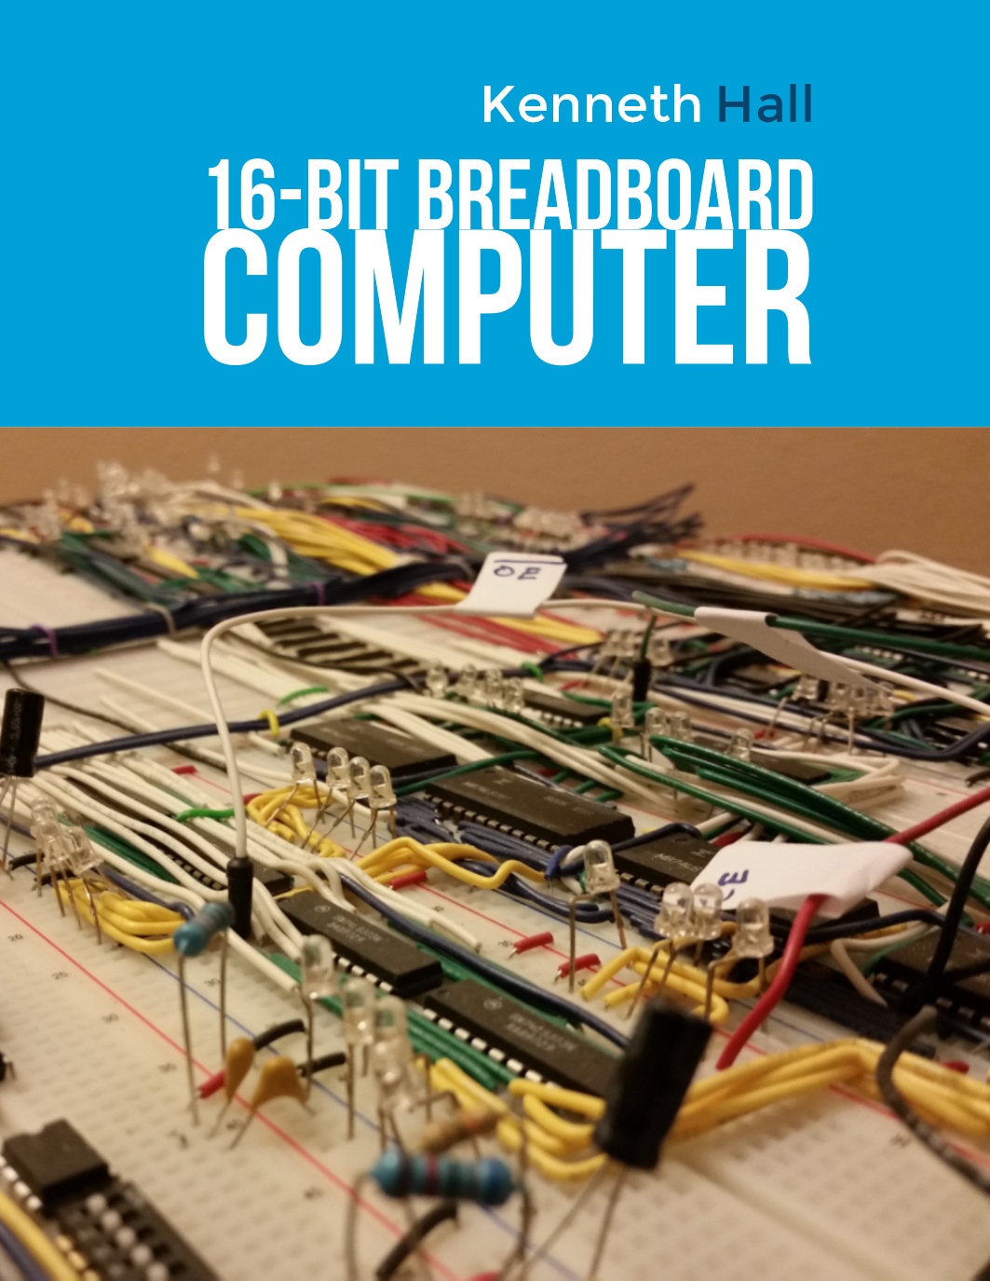

**16-Bit Breadboard Computer Report**

**Prepared By**

**Kenneth Hall**

**Spring 2018**

**Austin, Tx**

**CONTENTS**

**TABLES iv**

**FIGURES v**

**EXECUTIVE SUMMARY vi**

**1.0 INTRODUCTION 1**

**2.0 DESIGN PROBLEM STATEMENT 2**

**3.0 DESIGN PROBLEM SOLUTION 2**

**4.0 DESIGN IMPLEMENTATION 4**

**4.1 Bus 3**

**4.2 Clock and Reset 3**

**4.3 Debug 3**

**4.4 Program Counter 3**

**4.5 Memory 3**

**4.6 Register File 3**

**4.7 Arithmetic Logic Unit 3**

**5.0 CONCLUSIONS 8**

**REFERENCES 9**

**APPENDIX A – [TITLE OF FIRST APPENDIX]** *[Insert the appendix title.]***A-1**

**APPENDIX B – [TITLE OF SECOND APPENDIX]B-1**

**TABLES**

1 *Memory logic truth table* 7

2 *[Title of second table] [etc.]*

*[Etc.]*

*[The list of tables follows the table of contents and is also page numbered with a lowercase Roman numeral. Note that the list of tables and the following list of figures are two separate pages.]*

**FIGURES**

0 *16-bit computer layout.* 7

1 *16-bit computer, top-down.* 7

2 *16-bit computer, top-down, left [etc.]*

3 *16-bit computer, top-down, right [etc.]*

4 *System clock, top-down [etc.]*

5 *System clock layout [etc.]*

6 *Debug, top-down [etc.]*

7 *Debug layout [etc.]*

8 *Program counter, top-down [etc.]*

9 *Program counter layout [etc.]*

10 *Memory, top-down [etc.]*

11 *Memory layout [etc.]*

12 *Memory high to low byte datapath [etc.]*

13 *Memory logic simplification [etc.]*

14 *Register file, top-down [etc.]*

15 *Register file layout [etc.]*

16 *ALU, top-down [etc.]*

17 *ALU layout [etc.]*

*[The list of figures follows the table of contents and is also page numbered with a lowercase Roman numeral. Note that the list of figures and list of tables are two separate pages.]*

**EXECUTIVE SUMMARY**

This report details planning, design, and implementation of the 16-bit Breadboard Computer. Building the computer was a personal project started in Summer 2017 and will be completed Summer 2018. The goal of the project was to improve personal engineering skills by building a computer that could manipulate memory, perform logical and mathematical operations, and use control flow instructions. Building the computer provided an opportunity to research, design, model, and troubleshoot. Designing the computer included choosing the features of the microarchitecture. For example, lower cost might be chosen over speed, or simple and concise operating modes were preferred to complex and robust. Lastly, building each module required researching parts, minimizing control logic, modelling, and troubleshooting. This project provided the opportunity to develop and improve engineering skills and practices on a complex but transparent computer.

This goal of this project was to gain first-hand experience with electrical engineering design. This includes researching, designing, and organizing the architecture and layout. Additionally, this included troubleshooting, simulations, and measuring performance or response. The computer was built at a low enough level to demonstrate concepts and avoided schemes that were tedious or repetitive. For example, discrete arithmetic logic units (ALU) were used rather than adders built from logic gates. This computer provided an opportunity to decide between the benefits of different instruction set architecture (ISA) and microarchitectural choices. This includes evaluating what type of general-purpose register would best fulfill the project’s purpose.

Modules were designed and built to meet the project’s solution specifications to be educational. The modules were: system clock, bus, program counter (PC), memory, register file, ALU, and a user interface. The modules to be completed are the control store and instruction register. The system clock supported multiple speeds that show what the current instruction is doing or allow the computer to be stepped through by hand. The program counter allows for setting and resetting. Memory does not need to be fast but should also minimize control line overhead. The ALU should support basic operations, such as XOR or addition, but allow for future features. Lastly, the register file should be large enough for typical programs and minimize cost. Overall, modules were should be cost efficient but sufficient.

Implementing each module required designing schematics that fit the solution requirements to be functionally complete. This required researching parts, implementing features, and determining how the module will be controlled. For example, two 4-bit registers with a resetting feature might be passed over for one 8-bit register with no features. Additionally, implementation included the decision of choosing an EEPROM over logical gates to allow for future changes at the cost of complexity and cost. Lastly, this step required troubleshooting and test verification. This included checking ALU operating modes or troubleshooting an ICs set or reset feature.

Building the 16-bit computer was an incredibly frustrating, but rewarding experience. Building the computer tested my ability to initiate and work on a long-term project. The project improved my technical skills and reinforced classroom information. Unexpectedly, the project also tested my resolve and patience however, this taught me some unexpected lessons. I learned to not rush ahead. I learned how “weeks of working can save you hours of planning.” To avoid backtracking, I became disciplined and built without taking shortcuts. Overall, I’ve gained experience outside of the classroom that has given me the satisfaction of planning and executing a large project.

1. **INTRODUCTION**

This report explains the goal, solution, and implementation of the 16-bit computer. The next section details what the final intention of the project is and how building a computer will help meet those objectives. Afterwards, the report describes what properties and instructions the computer will have to meet the projects intention. This section also contains explanations for why the pros outweigh the cons for a specific module. Lastly, implementation the computer is described. This includes how the computer was build, components chosen, and the design layout. Building and developing a Turing Complete computer provided experience and the opportunity to learn engineering principles outside of the classroom.

**2.0 DESIGN PROBLEM**

The goal of this project was to design and build a 16-bit computer. Specifically: “…a mechanism that does two things: It directs the processing of information and it performs the actual processing of information” [1]. This computer would be able to store and retrieve data from memory, manipulate that data, and execute a program from a well-defined instruction set. For our purposes, the computer does not need to have an extensive set of instructions, such as multiplying or calculating a square root, but the capabilities should demonstrate mastery of concepts and principles.

Foremost, the computer should be designed with the intention of explaining its’ processing and design frequently. This means an overall concise, straight-forward, and intuitive layout and scheme. The computer should be able to operate such that micro-instructions can be clearly seen. Indicators, such as LEDs or seven-segment displays, should intuitively show the computers actions. Where appropriate, the user should be able to “look into” registers and see if everything is as it should be.

Secondly, all work should be modular, scalable, and easy to access. The layout should be highly organized. Currently, the computer has over 200 ft of wire; poorly planning one connection could cause one to four ICs having to be replanned—and that’s before troubleshooting to find out the problem!

Lastly, the computer should move and process data. The computer should at a minimum be able to: store and load data, perform simple mathematical and logical operations, and use control flow instructions. Working with 16-bit words should be prioritized over byte operand instructions. Addition should be one of the early data manipulation instructions completed. Typically, the modules are not completed simulatenously, so there is possibility to reduce hardware cost by sharing resources. For example, instead of using counter ICs, they could be substituted for registers and use the ALU to increment.

**3.0 DESIGN SOLUTION**

This section explains what solution was chosen for individual modules and their benefits or drawbacks.

The goal of the clock, reset, and debug modules was to provide an access point for operating the computer. The clock should be able to manually stop, started, and resumed. The clock should have an operating mode switch and step-through capabilities through a button. Additionally, the clock should run autonomously at multiple speeds. However, until the computer is mostly complete, a slower frequency is adequate for trouble shooting. Lastly, a reset button should be implemented that will reset system registers to expedite troubleshooting.

The program counter should contain the address of the next instruction to be executed. Therefore, the module should be able to easily increment its data. Additionally, the register will need to be set to allow for branch instructions.

Memory should accommodate word length instructions. It should be byte addressable to reduce backtracking for future features. Memory should have enough capacity to store a user program and have enough system space for future vector tables. Program length should accommodate the requirements to showcase a partical feature of the computer. This typical program might load a value, load another value, add them, branch if even or odd, and store them accordingly. For this reason. Additionally, the mechanism used for memory does not need to be particularly fast. Many of the ICs used have an execution time on the order of $100 μs$ or less, but the computer will typically be stepped through by hand and examined afterwards.

The register file should have enough capacity to facilitate user programs. Any registers used in hardware will not be accessible by the user and can be omitted from this module.

The arithmetic logic unit (ALU) should prioritize frequently used operations. ADD and AND operations account for 14% of 80x86 instructions [quantitative A-16], therefore they will be the first to be implemented in our instruction set. Richer instructions should be implemented, but not at the cost of increased complexity.

**4.0 DESIGN IMPLEMENTATION**

This section explains how each completed module was developed. Additionally, all truth tables, signal simplifications, and IC operating modes are shown here. Some signals, such as ground or LED connections, are omitted for clarity.

In the following diagrams, filled arrowheads represent data movement and open arrow heads represent control lines. Many lines are abbreviated with a slash and a number, such as 16 lines to the bus. Several lines are omitted, such as LEDs, their intermediate registers, or $V_{CC}$. Since it is not possible to “look into” an IC directly, a second register is sometimes added that latches a value.

In each photo, a black wire is used for ground and red for $V_{CC}$. White represents 16-bits of data usually to and from the bus. Red and black are sometimes used for this signal. Blue show control signals. Yellow and green are reserved for signals within the module. Red sometimes carries this signal. For example, isolated logic gates within a module might use these colors.

The completed modules are: bus, clock, debug, program counter, MDR, MAR, register file, and arithmetic logic unit. The modules in work are the control store, instruction register, and pre-processor memory writer. Figures n-n show the full computer.

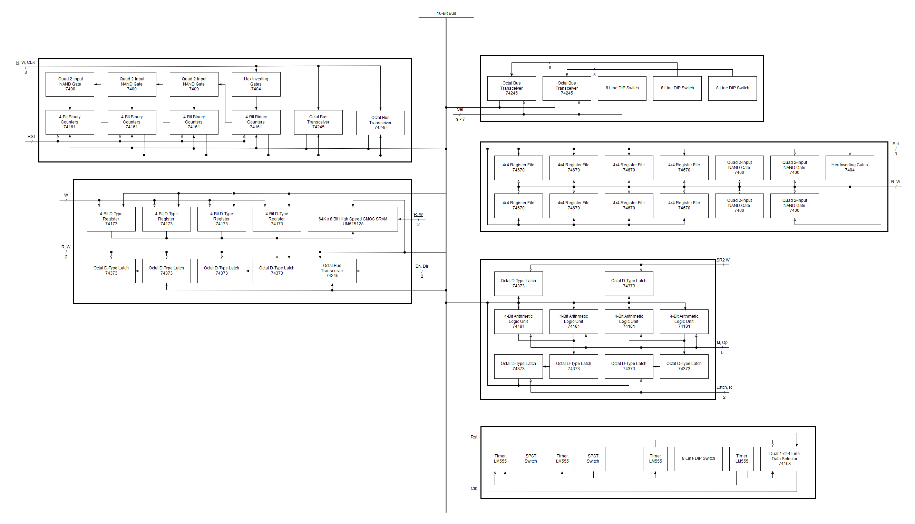

**Figure 0. 16-bit computer layout.**

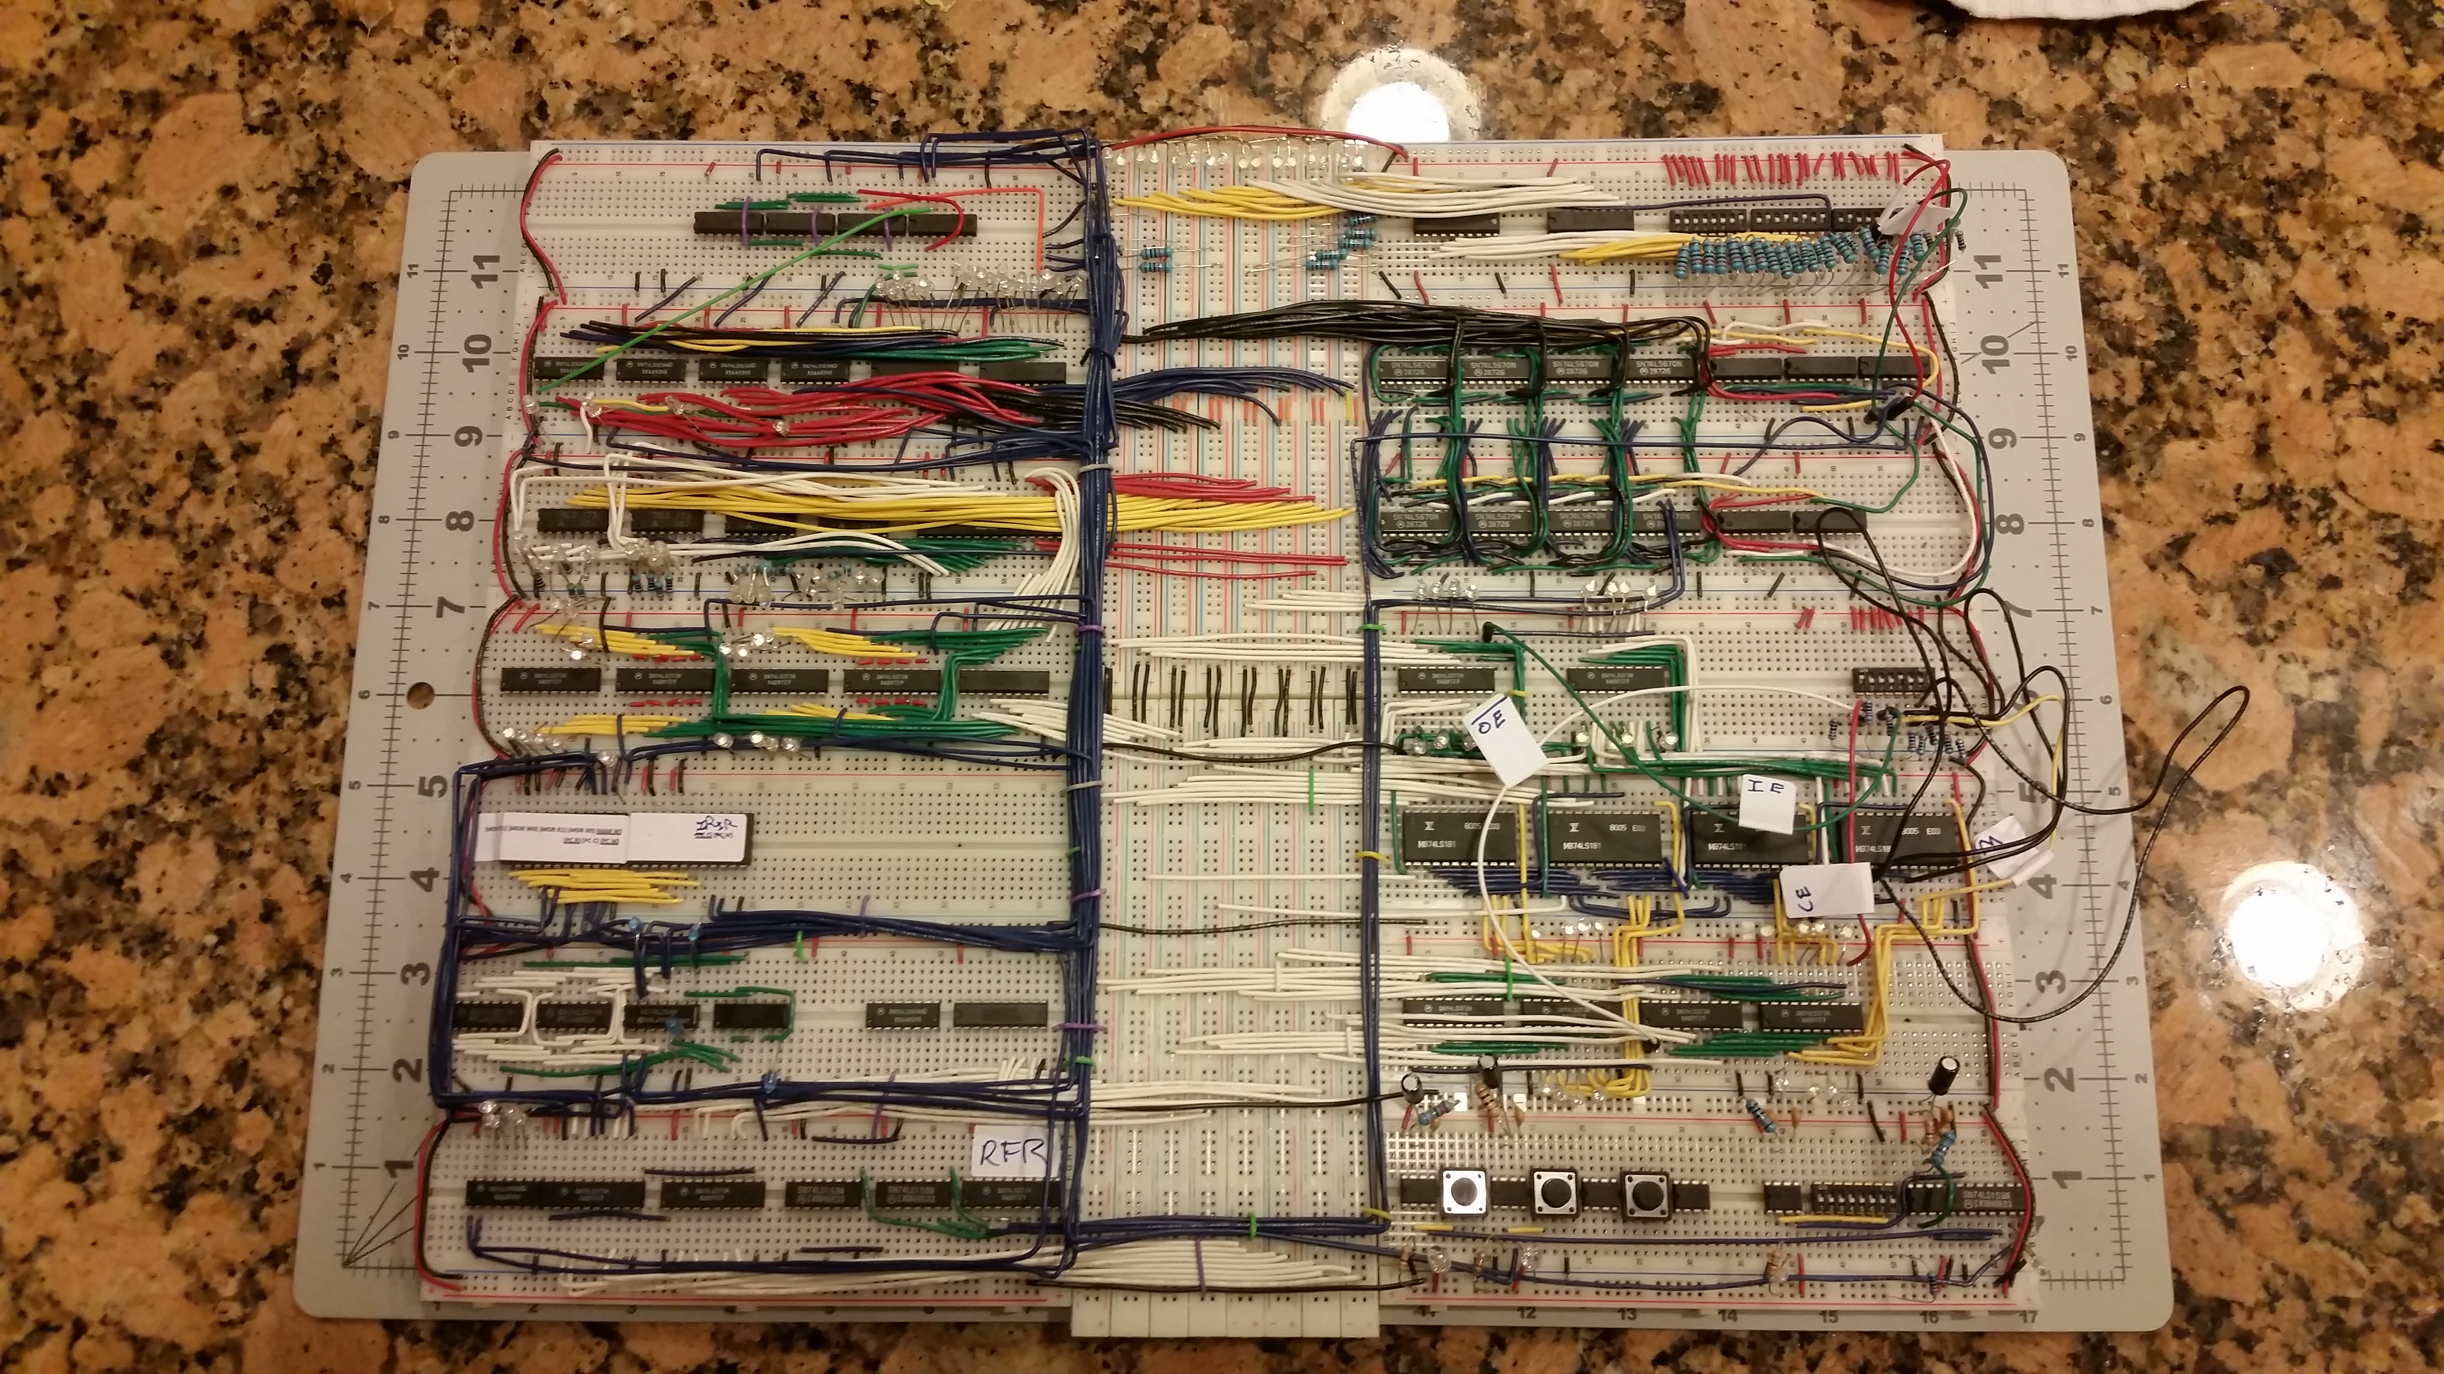

**Figure 1. 16-bit computer, top-down.**

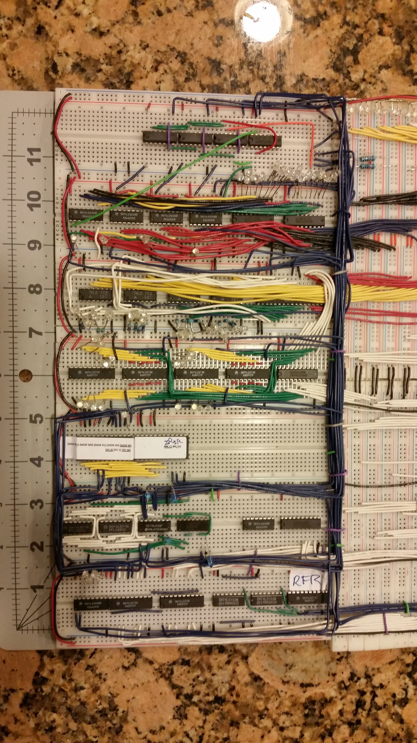

**Figure 2. 16-bit computer, top-down, left.**

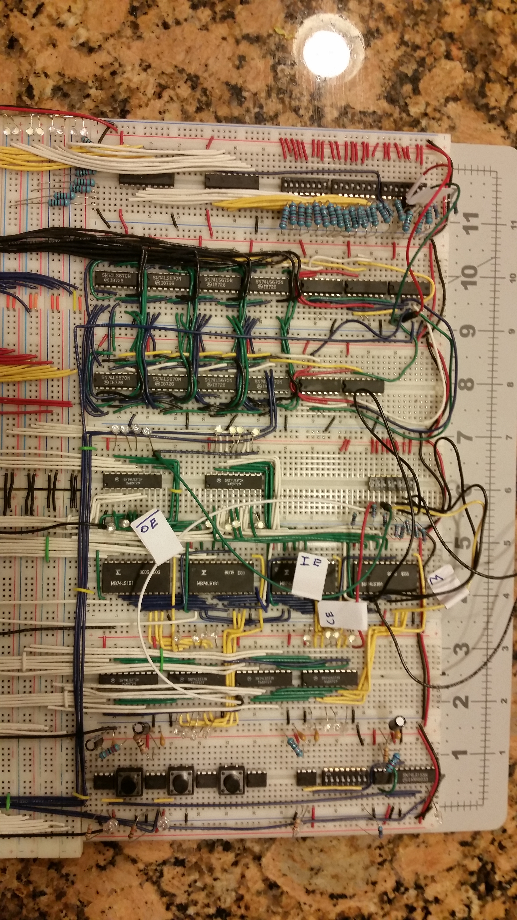

**Figure 3. 16-bit computer, top-down, right.**

**4.1 Bus**

The bus transports all non-control signals for the computer. It is make of 32 breadboard terminal strips, 16 LEDs, and 16 resistors. The terminal strips are divided into 16 pairs arranged vertically. Each LED corresponds to one bit out of 2 byte words. When the LED is on, that bit is high.

**4.2 Clock and Reset**

The system clock consists of three LM555 timers, one multiplexor 74LS153, two SPST switches, and one 8-line DIP switch. The configuration is shown in Figure n and Figure n.

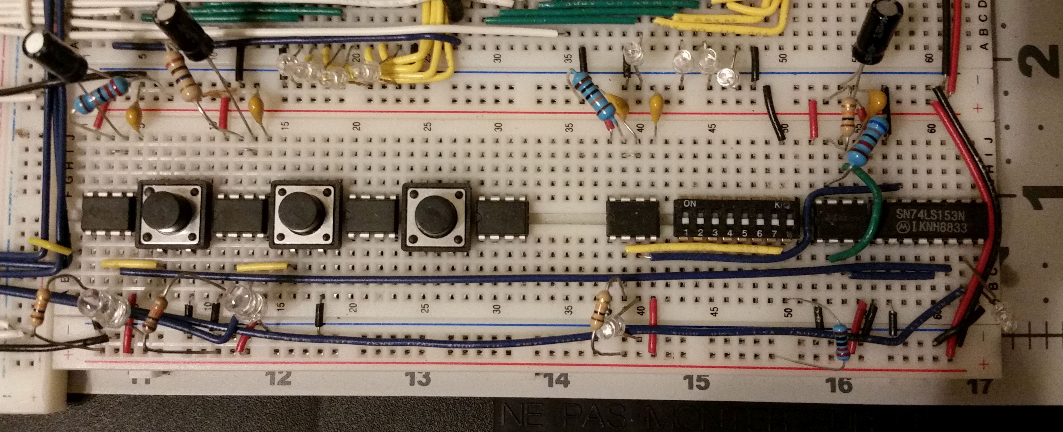

**Figure 4. System clock, top-down.**

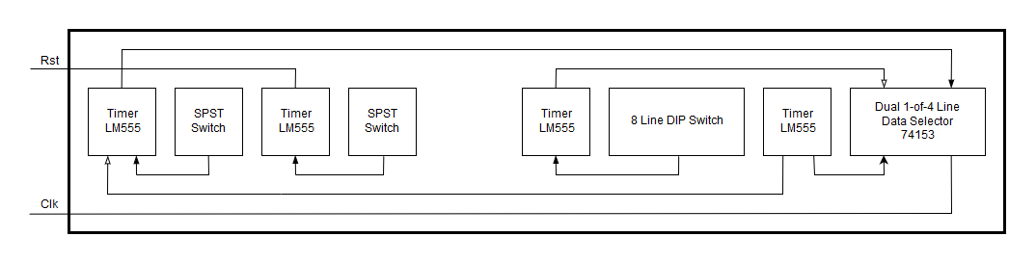

**Figure 5. System clock layout.**

The 8-line DIP switch selects one of two modes: a 1 Hz 50% duty square wave or a debounced SPST to step through clock cycles. The DIP switch implements only one of eight signals with room for future features. Similarly, the multiplexor implements two of four lines; one future operating mode might be on the order of 100 Hz to execute larger programs. Another option is to use the time required by the slowest IC. Additionally, the circuit also includes a master reset to set PC and other modules to zero. All SPST and DIP switches in this circuit are debounced with LM555s; these components were on-hand and ready to use. In the future, a simpler RC circuit will be used to reduce overall cost.

**4.3 Debug**

The debugging module contain two octal bus transceiver 74LS245 and three 8-line DIP switches. The configuration is shown in Figure n and Figure n.

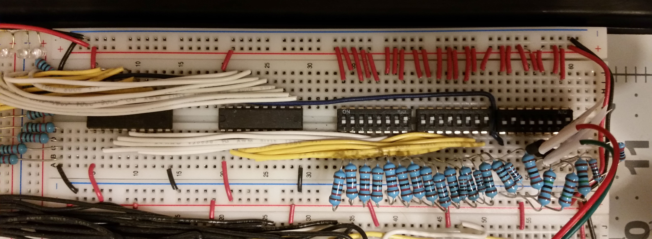

**Figure 6. Debug, top-down.**

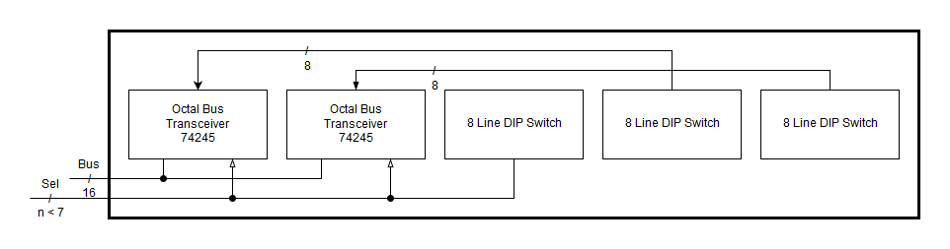

**Figure 7.** **Debug layout.**

Two switches select what bit is to be written to the bus; the last switch enables the two octal bus transceivers. The unused positions in this switch are used for quick testing and debugging while building new modules.

**4.4 Program Counter**

The program counter (PC) consists of four 4-bit binary counters, two 8-bit tristate buffers, three quad 2-input NAND gates, and hex invertering gates. The configuration is shown in Figure n and Figure n.

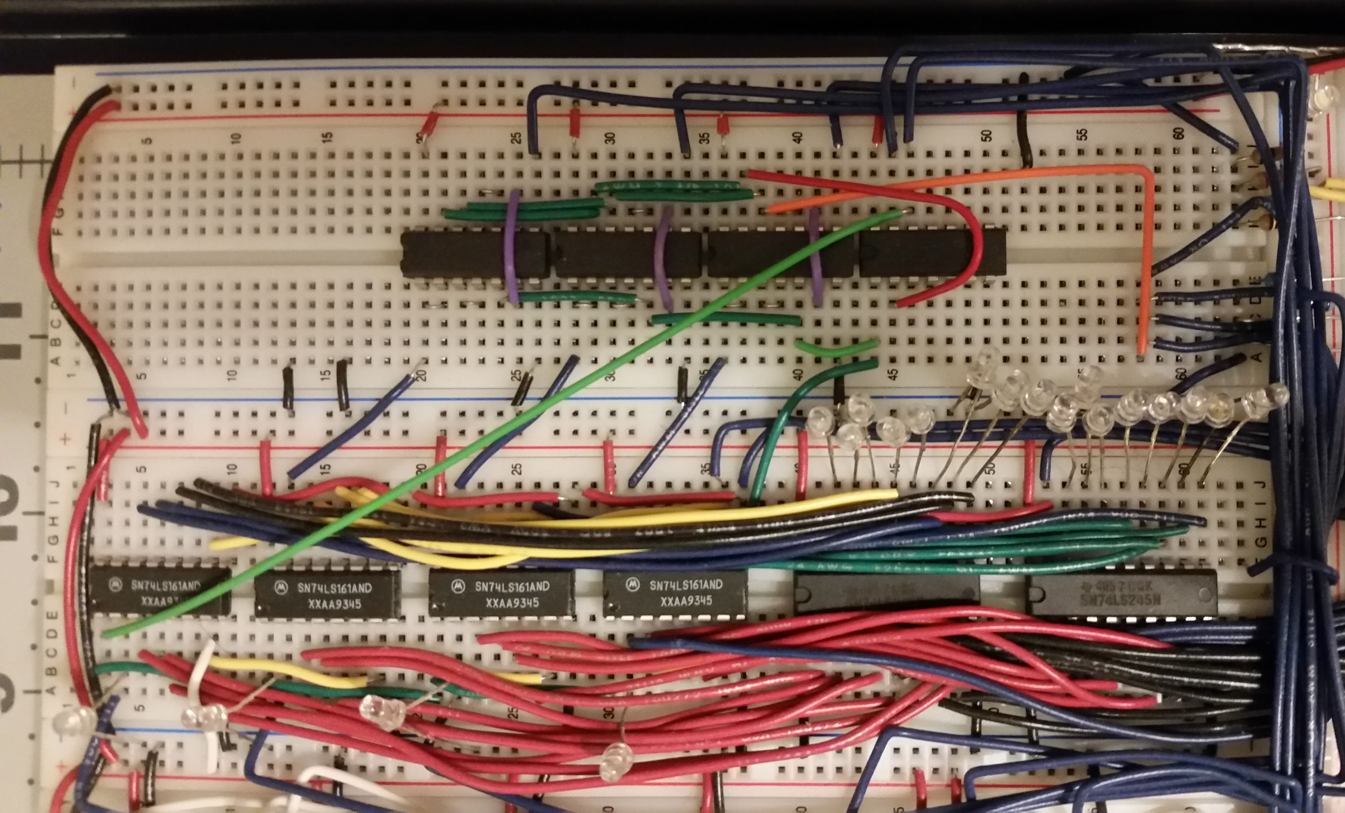

**Figure 8. Program counter, top-down.**

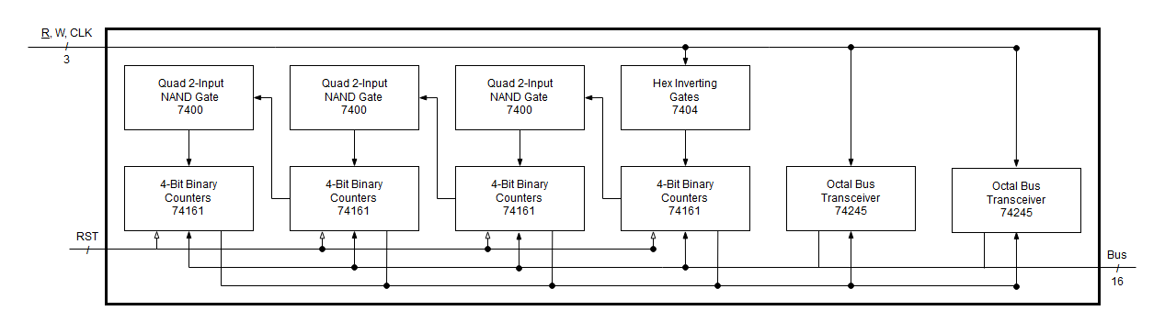

**Figure 9. Program counter layout.**

The 74LS161 binary counter provided an incremented address with each clock pulse. Additionally, the address can be set or reset. All output bits were connected to 74LS245 buffers. All input setting bits were tied to the bus. The active low master reset (MR) signal was connect to a master reset SPST switch. The clock bit, CP, was not directly connected to the system clock. Since four binary counters were connected in series, the first counter would use the clock signal for normal operation, and the remaining counters would use the previous counter’s terminal count output bit (TC). This bit signaled when a counter had counted its’ full range. However, resetting the counters required a clock pulse. Therefore, the counters would need their respective clock or TC signal at certain times, and need to receive a coordinated pulse to reset. This logic was reduced with LogicAid and then converted to a NAND gate equivalent to reduce cost. The 74LS00 quad-NAND gate and the 74LS04 inverter were used to create this multiplexer.

The 74LS245 octal bus transceiver was used to buffer the program counter’s output. Since the buffer was used for outputting to the bus only, the direction bit (DIR) was always set in that direction. Could have used a diff chip… The enable bit (E), was used to control when the PC sends data to the bus. The remaining lines consist of input to output pairs.

**4.5 Memory**

The memory module contains one 64K x 8 CMOS Sram UM61512A, four 4-bit D-Type Register 74LS173, four octal D-Type latch 74LS373, one octal bus transceiver 74LS245, two dual 4-input AND gate 74LS21, one hex inverting gate 74LS04, and one quad 2-input OR gate 74LS32. The configuration is shown in Figure n and Figure n.

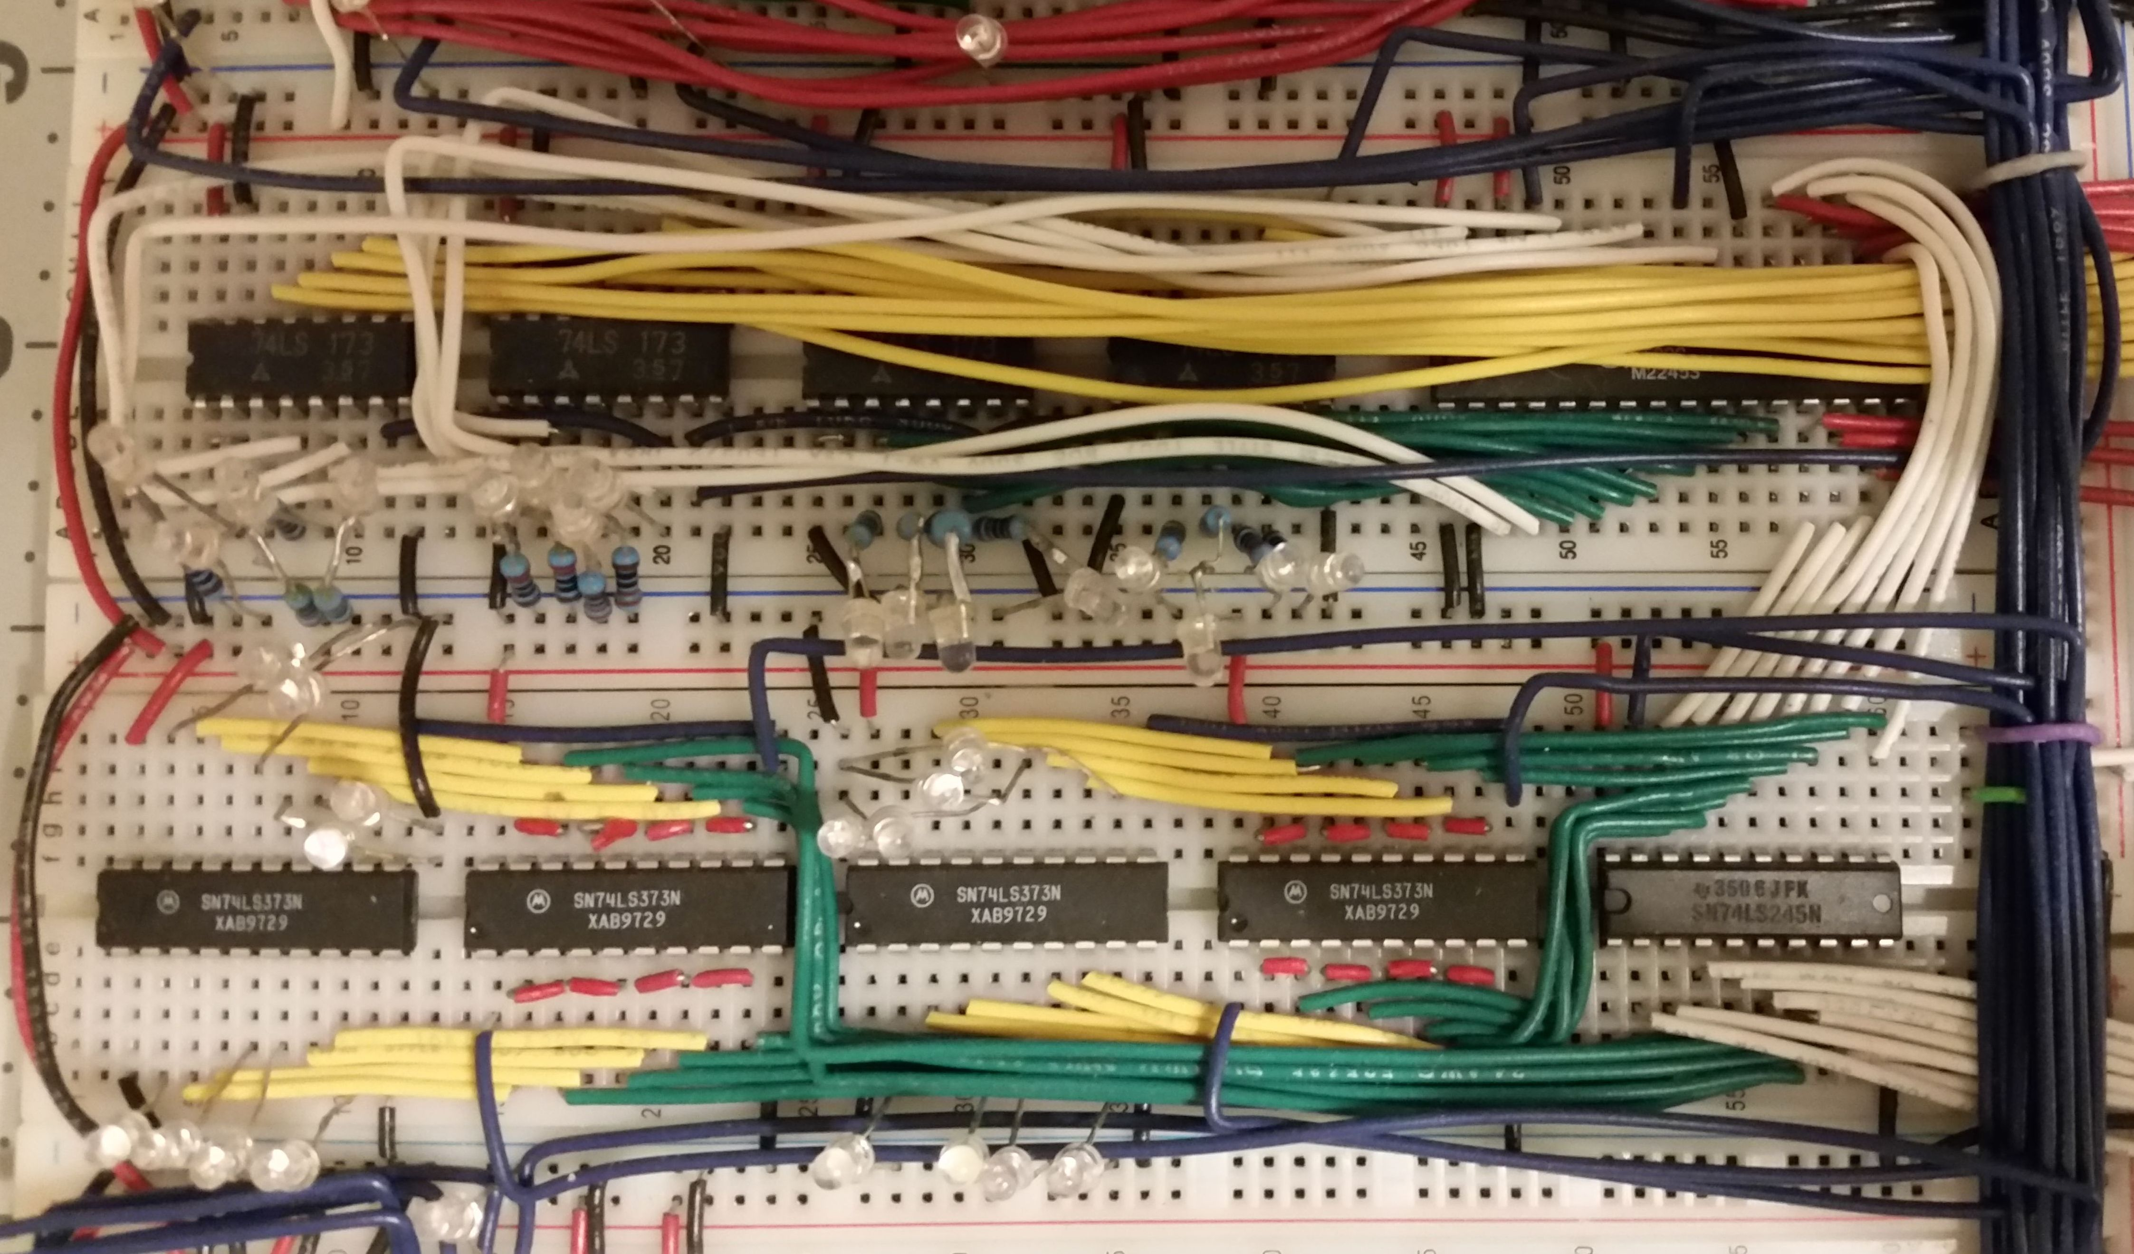

**Figure 10. Memory, top-down.**

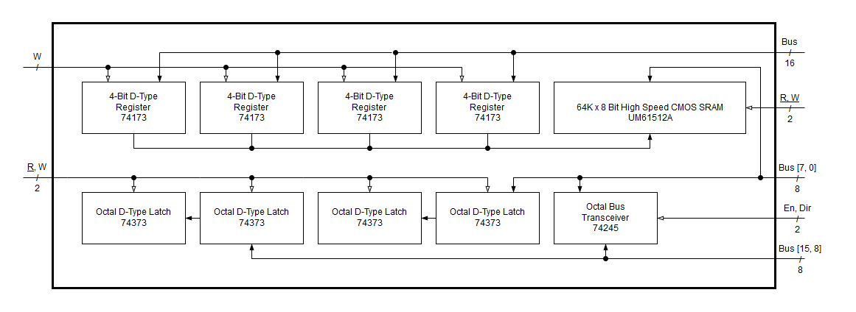

**Figure 11. Memory layout.**

The memory address register (MAR) received a 16-bit address from the bus. This value determined what place in memory was to be accessed. A write enable bit, controlled by the control store, would then allow an address to be sent to memory. The memory data register (MDR) contained four octal D-type latches. However, the latches were connected in series and held identical values—this allow LEDs to be connected to see what values the latch pairs held. Since memory was byte addressable, the high and low bytes of the bus had to be both accessable by the MDR. The octal bus transceiver 74LS245 was configured to allow the high byte to be copied onto the lower byte on the bus. This data path is shown in Figure n in red.

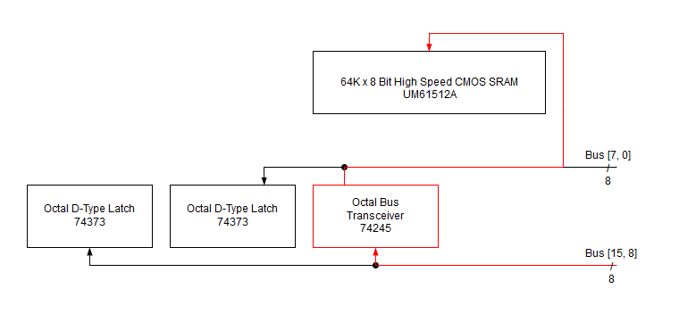

**Figure 12. Memory high to low byte datapath.**

At this point, the control store has to keep track of the following MDR signals: read byte 1, read byte 0, write byte 1, write byte 0; the signals to write to memory are: memory read, memory write, tri-state buffer enable, tri-state buffer direction. However, only certain permuations of these signals are ever used; the truth table, shown in Table n, shows all possible states.

**Table 1.** **Memory logic truth table.**

|  |  |  |  |  |  |  |  |  |
| --- | --- | --- | --- | --- | --- | --- | --- | --- |
| w1 | w0 | r1 | r0 | r mem | w mem | 3s dir | 3s en |  |
| 0 | 0 | 0 | 0 | 1 | 1 | - | 0 | MDR to bus |
| 0 | 0 | 0 | 1 | 1 | 0 | 1 | 1 | r1 to mem |
| 0 | 0 | 1 | 0 | 1 | 0 | - | 0 | r0 to mem |
| 0 | 0 | 1 | 1 | 1 | 1 | - | 0 | Default (off) |
| 0 | 1 | 0 | 0 | 1 | 1 | - | 0 |  |
| 0 | 1 | 0 | 1 | 1 | 1 | - | 0 |  |
| 0 | 1 | 1 | 0 | 1 | 1 | - | 0 |  |
| 0 | 1 | 1 | 1 | 0 | 1 | - | 0 | Mem to R0 |
| 1 | 0 | 0 | 0 | 1 | 1 | - | 0 |  |
| 1 | 0 | 0 | 1 | 1 | 1 | - | 0 |  |
| 1 | 0 | 1 | 0 | 1 | 1 | - | 0 |  |
| 1 | 0 | 1 | 1 | 0 | 1 | 0 | 1 | Mem to R1 |
| 1 | 1 | 0 | 0 | 1 | 1 | - | 0 |  |
| 1 | 1 | 0 | 1 | 1 | 1 | - | 0 |  |
| 1 | 1 | 1 | 0 | 1 | 1 | - | 0 |  |
| 1 | 1 | 1 | 1 | 1 | 1 | - | 0 | Bus to MDR |

Since the memory and tri-state control signals are dependent on what byte is beign written or read, the number of control lines can be reduced from eight to four. The table was entered into logic aid to find a minimally reduced solution. The LogicAid simplification routine is show in Figure n.

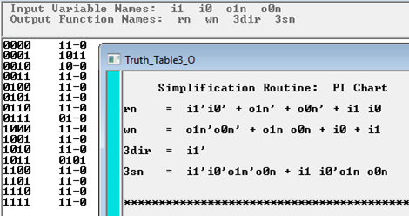

**Figure 13. Memory logic simplification.**

Lastly, these equations were implemented with 4-input AND 74LS21 and 2-input OR 74LS32 to reduce component quantity. This is shown shadowed in grey in the previous Figure n.

**4.6 Register File**

The 8 by 16bit register file contains eight 4x4 register file 74LS670, four Quad 2-Input NAND gate 74LS00, and a hex inverter 74LS04. The configuration is shown in figure n.

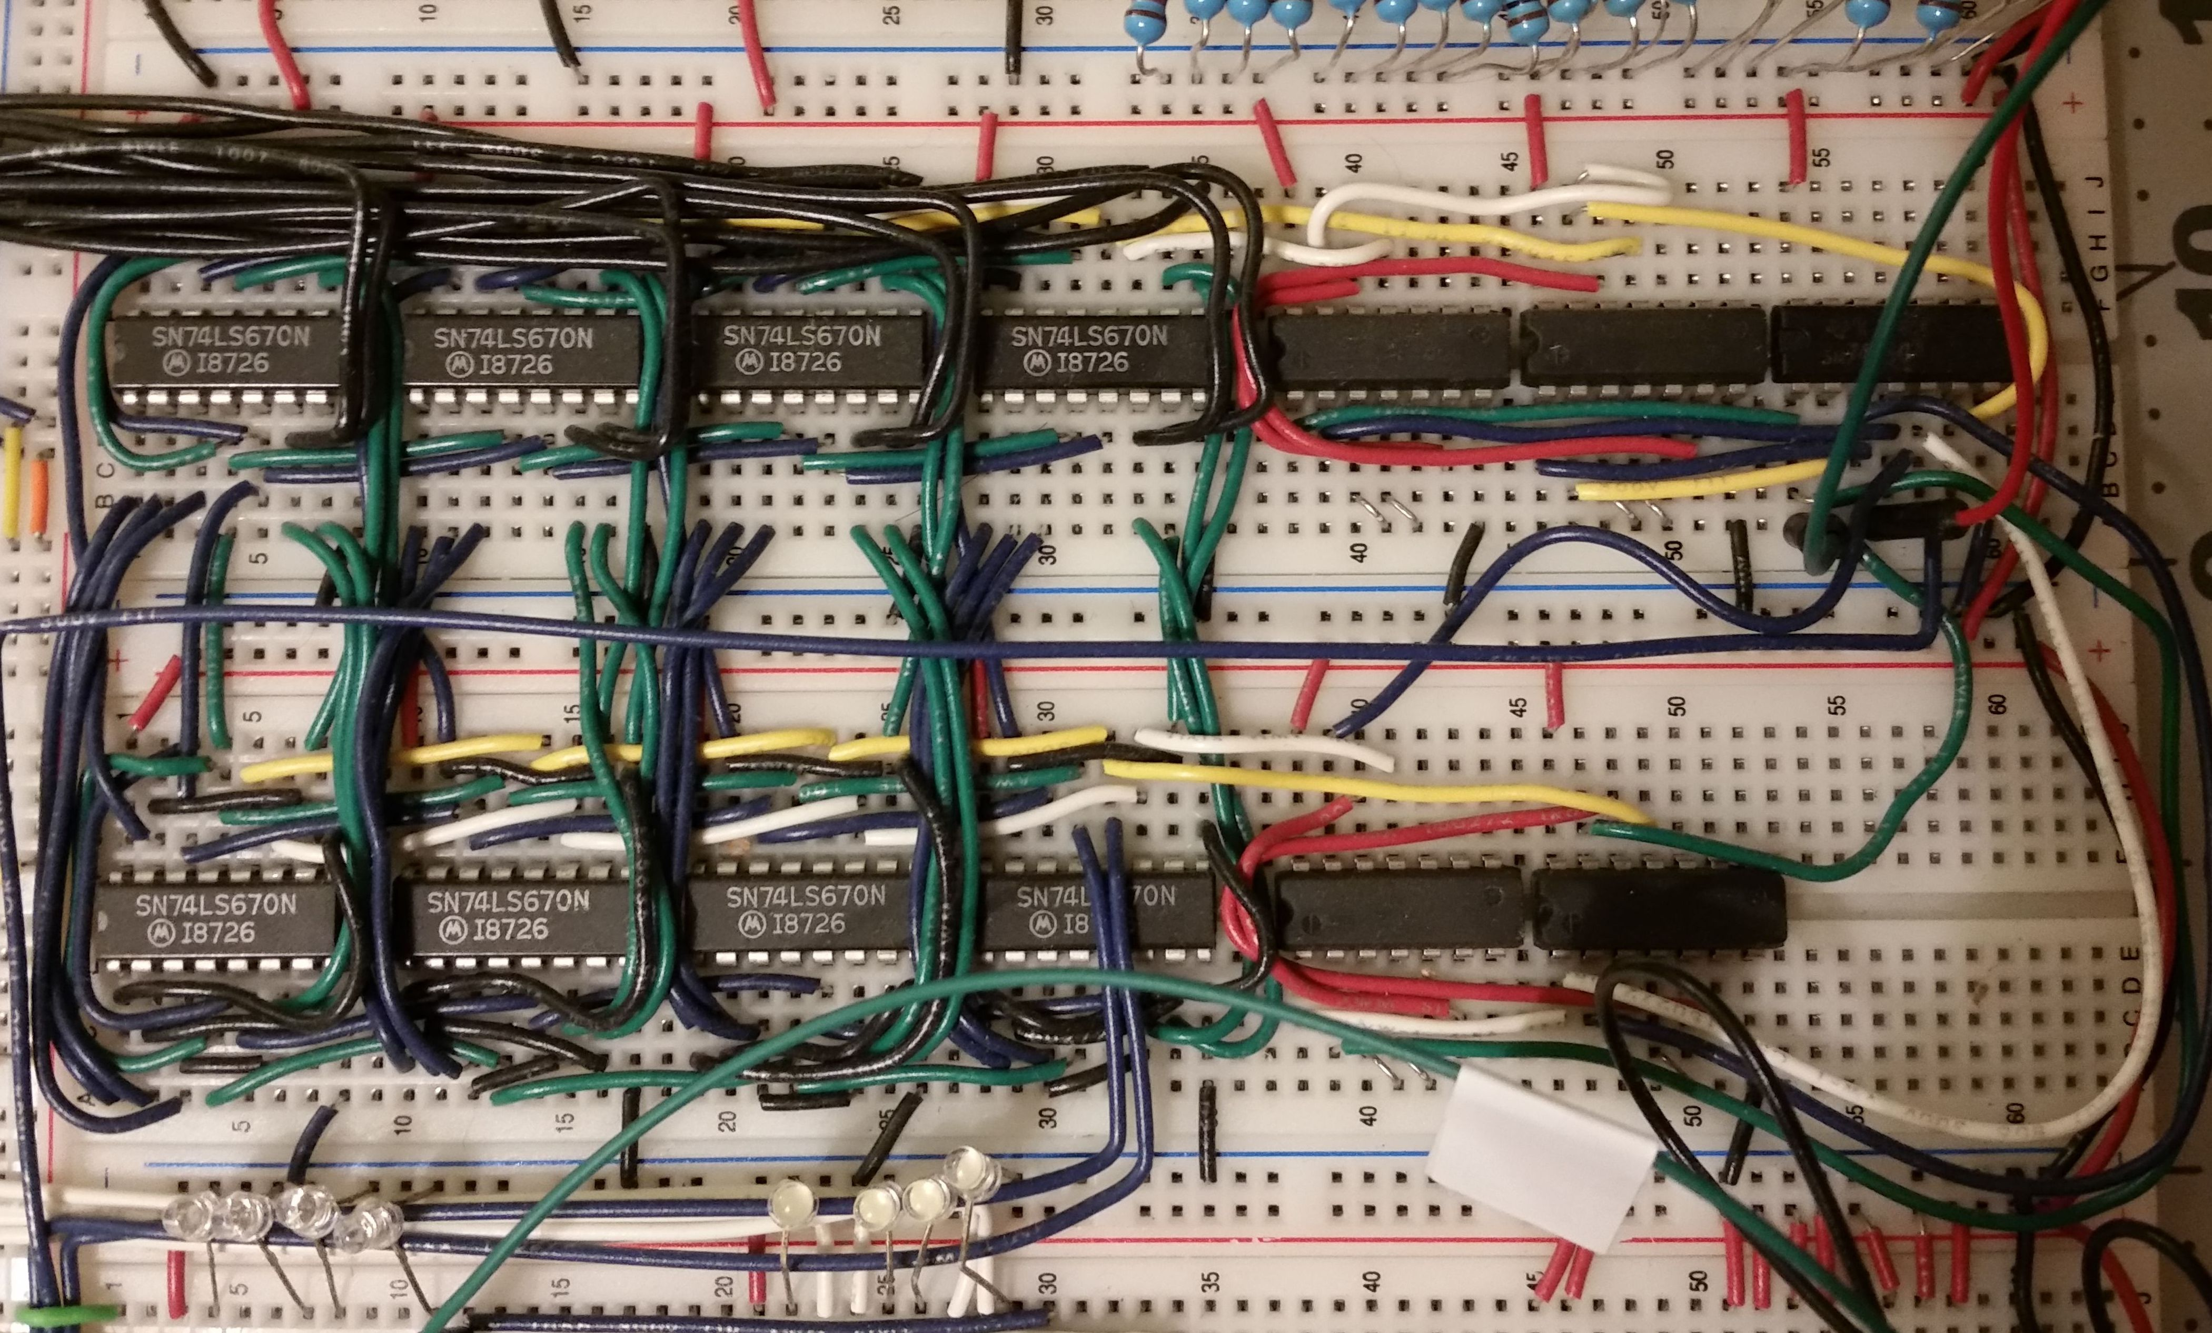

**Figure 14. Register file, top-down.**

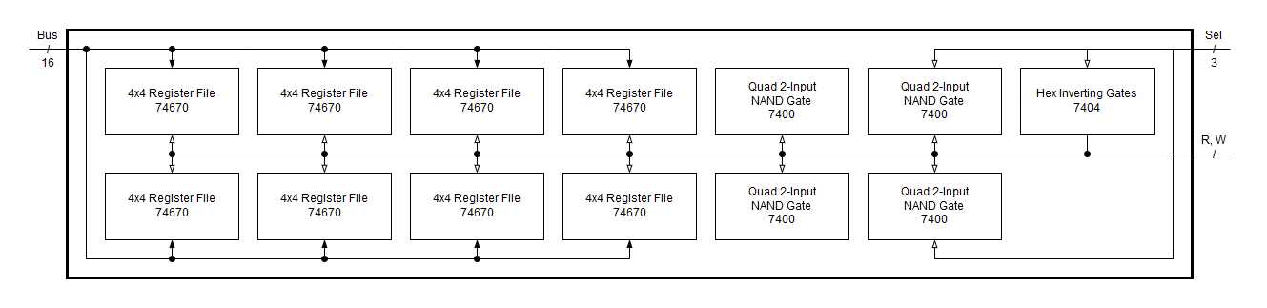

**Figure 15. Register file layout.**

This setup contains two sets of four 74LS670, where each set stores four 16-bit registers. Their inputs and outputs are both tied to the bus. A tri-state buffer is not used, so there is no way to see into a selected register without sending its’ data to the bus. Each set of the four 74LS670 has four control lines: read, write, and two bits to select a register. The 74LS670 allows for simultaneous read and write, but it is not used in the model. To avoid using a total of eight control lines, their logic was reduced to Equations 1 through 4, shown below

|  |  |
| --- | --- |
| $$r_{0}=r^{'}+w+a_{2}$$ | (1) |
| $$w_{0}=w'+r+a_{2}$$ | (2) |
| $$r_{1}=a_{2}'+r^{'}+w$$ | (3) |
| $$w_{1}=r2^{'}+w^{'}+r$$ | (4) |

where $a_{2}$ represents the most significant bit of which register to select. These reduced equations were implemented in the control store.

**4.7 Arithmetic Logic Unit**

The arithmetic logic unit (ALU) consists of six octal d-type latch 74LS373 and four 4-Bit ALU 74LS181. Their configuration is shown in Figure n.

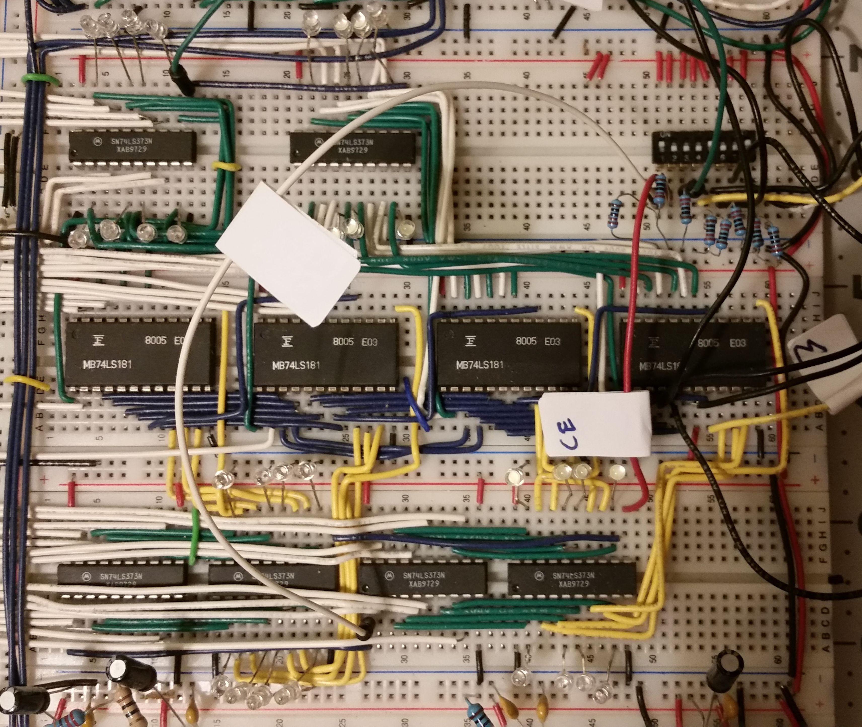

**Figure 16. ALU, top-down.**

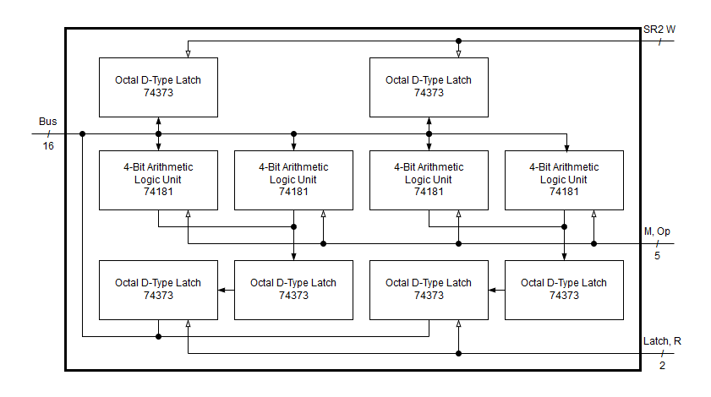

**Figure 17. ALU layout.**

Four 4-bit arithmetic logic unit 74LS181s were chosen to perform data manipulation operations. Alternatively, mathetmatical operations could have been implemented through an array of full adders and the logical operations could be derived from available logic gate ICs. However, this would have increased cost and required additional time for implementation and troubleshooting. This is not necessarily negative, but many of these concepts or techniques have been shown in previous modules. Therefore, it was decided to move forward with the 74LS181 to expedite development of future modules.

The 74LS181 provides sixteen operations, with modes for active high or active low operands. The pins used include the four input and output lines, mode select, four function select lines, carry in, and out lines. Planned supported operations include XOR, AND, ADD, NOT, and L/R Shift with active high operands only. This will allow the control line count for mode selection to be reduced from five to three with room for adding more operands in the future. Notably, two lines, carry generate and carry propagate were not used. These are to be used with a lookahead carry generator 74LS182 for quicker calculations. This capability will be considered for future features.

Six octal d-type latch 74LS373s were used instead of the previously used 74LS173. These were chosen as they serve the functionality needed and would have fewer wires to connect. In this module, two octal latches stored the second source operant for the ALU. The remaining four are split into pairs; two contain the low byte of the value computer and two contain the high byte. This allows the computed value to be displayed through LEDs without sending the data to the bus.

**5.0 CONCLUSION**

Building the 16-bit computer was a challenging project that improved research, planning, and organizational skills. This included choosing the most efficient parts and schemes, determining what order to build the modules, and staying organized as modules were added to the computer. The computer is not perfect and more efficient implementations exist. At the beginning, troubleshooting was arduous; planning was sometimes rushed when new parts arrived or beginning a new segment. However, no matter how complicated or confusing development became, I was determined to complete my goal. Over time, my persistence paid off, troubleshooting went from days to hours. Newer modules were organized, accessible, and worked correctly on the first try. Making progress on a multi-month project that used information from previous classes was satisfying and enlightening. I am eager to utilize this experience, not just to complete the computer, but also in my future career.

**REFERENCES**

[1] [First source reference in IEEE format. First source reference in IEEE format. First source reference in IEEE format. First source reference in IEEE format.]

[2] [Second source reference in IEEE format. Second source reference in IEEE format. Second source reference in IEEE format. Second source reference in IEEE format.]

*[Etc.]*

*[Note that the brackets around each number (unlike the other brackets in this template) are required in a list of references. Each listed reference should be single spaced, with 1-1/2 space between references. This section is a listing of all references of source material. (See the General Specifications for Final Reports.) List the references in the same numbered order that they are cited in the text.* ***Note that this section does not have a decimal number.****]*

*[This page is the title sheet for the first appendix. All appendices must have a title sheet, with the title centered horizontally approximately a third of the way down the page. Be sure to give each appendix a descriptive title. No appendix can appear that has not been referenced in the text, and all appendices must be listed in the table of contents. This page receives the page number A-1, and the numbering system continues with A-2, A-3, etc. on the following pages.]*

**APPENDIX A – [TITLE OF FIRST APPENDIX]**

**APPENDIX A – [TITLE OF FIRST APPENDIX]**

[Text, figures, tables, or chart. Text, figures, tables, or chart. Text, figures, tables, or chart. Text, figures, tables, or chart. Text, figures, tables, or chart. Text, figures, tables, or chart. Text, figures, tables, or chart. Text, figures, tables, or chart. Text, figures, tables, or chart. Text, figures, tables, or chart. Text, figures, tables, or chart. Text, figures, tables, or chart. Text, figures, tables, or chart. Text, figures, tables, or chart. Text, figures, tables, or chart. Text, figures, tables, or chart. Text, figures, tables, or chart. Text, figures, tables, or chart. Text, figures, tables, or chart. Text, figures, tables, or chart. Text, figures, tables, or chart. Text, figures, tables, or chart. Text, figures, tables, or chart. Text, figures, tables, or chart. Text, figures, tables, or chart. Text, figures, tables, or chart.v Text, figures, tables, or chart. Text, figures, tables, or chart. Text, figures, tables, or chart.**]**

*[Repeat the appendix letter and title on the first page after the title sheet. Place an en dash between the appendix letter and title. There are no other requirements for the appendix. Use the space in this appendix for figures, tables, coding technical details, photographs, sketches, or any other type of data that is too extensive or distracting to place in the main text, even though it is relevant and necessary information.*

*[Same instructions as for Appendix A. This page is the title sheet for the second appendix. This page receives the page number B-1, and the numbering system continues with B-2, B-3, etc. on following pages.]*

**APPENDIX B – [TITLE OF SECOND APPENDIX]**

**APPENDIX B – [TITLE OF SECOND APPENDIX]**

[Text, figures, tables, or chart. Text, figures, tables, or chart. Text, figures, tables, or chart. Text, figures, tables, or chart. Text, figures, tables, or chart. Text, figures, tables, or chart. Text, figures, tables, or chart. Text, figures, tables, or chart. Text, figures, tables, or chart. Text, figures, tables, or chart. Text, figures, tables, or chart. Text, figures, tables, or chart. Text, figures, tables, or chart. Text, figures, tables, or chart. Text, figures, tables, or chart. Text, figures, tables, or chart. Text, figures, tables, or chart. Text, figures, tables, or chart. Text, figures, tables, or chart. Text, figures, tables, or chart. Text, figures, tables, or chart. Text, figures, tables, or chart. Text, figures, tables, or chart. Text, figures, tables, or chart. Text, figures, tables, or chart. Text, figures, tables, or chart.v Text, figures, tables, or chart. Text, figures, tables, or chart. Text, figures, tables, or chart.**]**

*[Same instructions as those for the first appendix.]*